Paradies Gift Shops Hiring!!

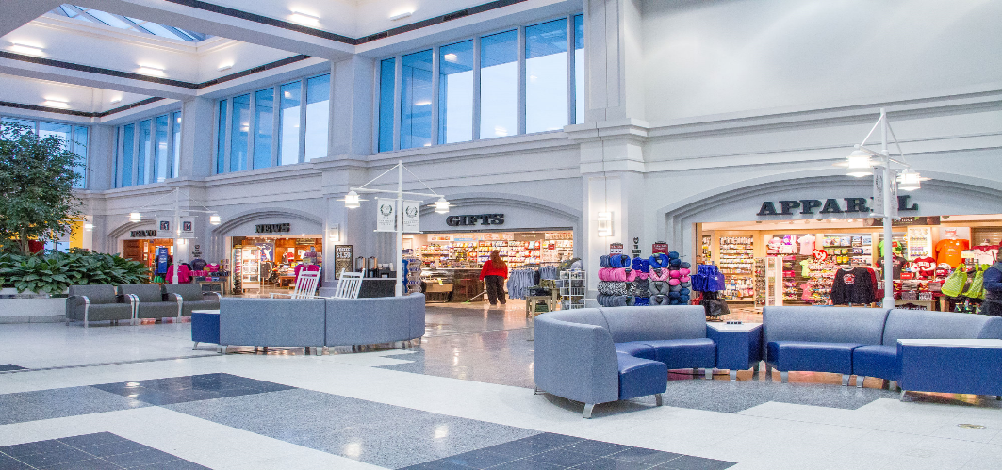

Paradies Gift Shops
Columbia Metropolitan Airport Location
Hiring for the following:
Full-time Management position
Full and Part-Time Sales Associate positions
Associates at The Paradies Shops use First Class Service standards each and every day to assist customers and process sales transactions. A typical day includes greeting customers as they enter the stores, assisting customers in making purchase decisions, answering questions regarding location, price and use of merchandise, processing sales transactions and thanking each customer for shopping with The Paradies Shops. Sales Associates take care of each customer and go the extra mile to make each customer feel like he or she is #1.
Applicants must have strong customer service and effective communication skills, with the ability to prioritize and handle several projects at once.
High school diploma or GED required. Ability to work any schedule - morning, evening, week days, weekends and holidays. One to two years prior retail or customer service experience preferred.
Please visit www.columbiaairport.com for a complete Paradies job description along with instructions on how to apply.

